To create a temporary record:
1. In the Loan mode, scan the patron's barcode.
2. On the Item menu, select Add Bibliographic. 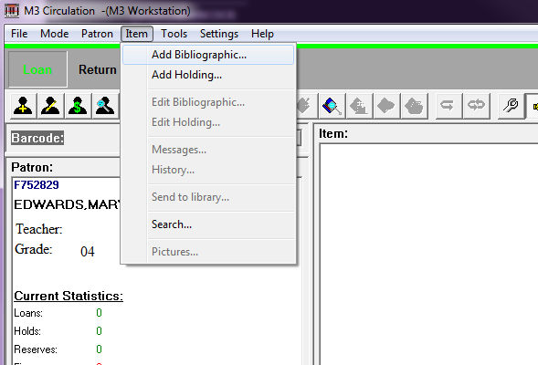
3. Select a template and then click OK. (Tip: Create an ILL template in Cataloging to include the fields you need, such as author and title.) This opens a blank Create New Bibliographic Record window. 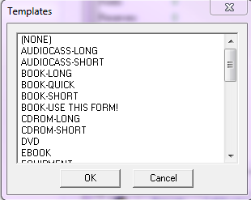
4. Add as little or as much bibliographic information as the record requires. In the 852 field, type the lending library name in the subfield a and "ILL" in subfield k. This step helps you track lenders, print lists and reports.
5. Click OK to accept.
6. At the prompt -Create Holding Record? - click Yes.
7. Add the call number on the book, if desired. (Tip: If you do not type in a call number, at least put ILL in the prefix - subfield k. This signals your patrons when they come across the item in your OPAC. It also gives more options in searching and sorting records in your database.)
8. Insert the barcode already on the book into the 852#p, if this does not conflict with your library's barcode range. Assign the item group. (Tip: Create an ILL item group in Group Editor.)
9. Select the Temp check box before saving. This marks the record for deletion upon return. 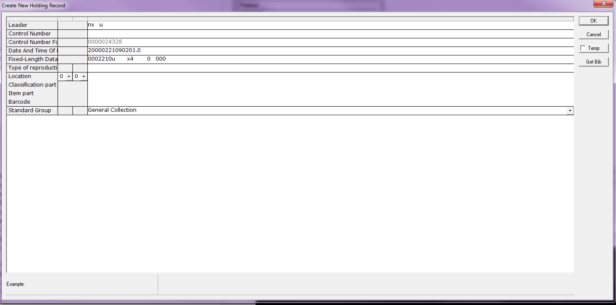
10. Click OK to save and the item is immediately checked out to the patron.
When the item is returned and you scan the barcode on the book, the temporary record created is automatically deleted. The item is no longer shown in your OPAC, but the record is still available in your database for statistical or other reports.

